XI. TACTICAL THEME: CUTTING LINES OR DAMMING
Prepared by: GM Bong Villamayor
Powerchess Asia

This tactical theme focuses on the cutting the protection of pawns and pieces, making it possible to continue an attack on a specific target. The main objective is either winning material or mating the opposing king.
Instructions: Two solutions one for White and one for Black!

1. W/B 2. W/B
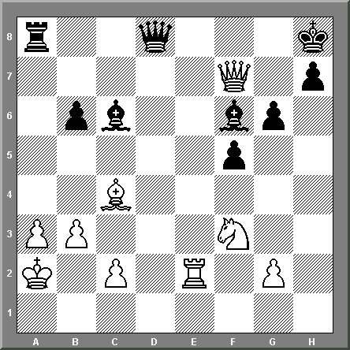
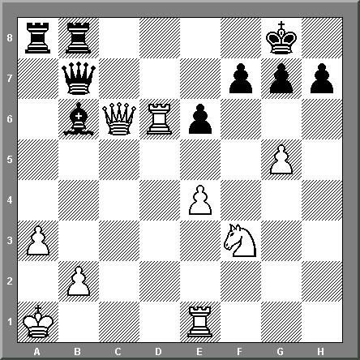

3. W/B 4. W/B
